Week 9– Datasets and LINQ

FORM1
Today we will look at building a simple two-form application based on the student database that we created in last week’s lab session. You will need to recreate the database in a new project for this week. The SQL and steps to do this are in last weeks folder on the ELP.
The purpose of today is to use datasets and LINQ queries. At times it may not seem that we are doing things as efficiently or elegantly as possible, and that is certainly true as was are trying to get experiment with the technology rather than produce the most beautiful system. We will not be using any of the ADO1 procedures in creating our application.
The first screen should contain only a simple data grid view. We are going to use data binding to connect the dataset to the DataGridView. In order to populate the dataset we are going to use and SQL query.
The alternative to this approach is to the write a LINQ query which would produce the same set of results. If you have time at the end of the day you are encouraged to rewrite this static SQL call so that it is in native LINQ. The only issue with LINQ is that often native SQL is simpler and easier to produce the solution we want. In this case, we are aggregating the marks for a particular student to show their averages. And there is also an outer join (Left) to bring back all the students even if they do not have any marks. We did cover some of these elements during the lecture on LINQ however due to the aggregation; this is fiendishly difficult, you are encouraged to try however without already being proficient in linq it will be a significant challenge. And this is when a pragmatic solution may be more desirable than an ideal Solution.
The SQL is as follows.
SELECT Student.studentId, Student.stuName,
Count(mark) AS MarksAvailable,
Avg(mark) AS AvrageMark
FROM Student LEFT JOIN marks ON Student.StudentID = marks.studentID GROUP BY Student.studentId, Student.stuName;

Use SQL above to populate a dataset, and then dynamically link the dataset to a DataGridView. The DataGridView.
You now need to make sure the user is unable to edit the data in the datagrid view, we covered this in the lecture, and you need to add this to the code so that no modification is possible.

Your initial screen should look at little like the following.
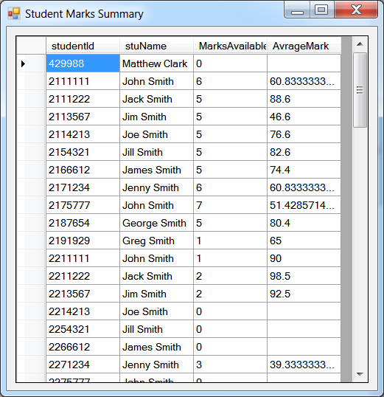

Adding Events.
When a user double clicks on a row or a cell, we need to determine the row being selected. We can do this with the following two statements. The first relates to when a cell is clicked and the second is when a row is selected.
DataGridView_OBJECT.CurrentCell.RowIndex
DataGridView_OBJECT.SelectedRows[0].Index

Both of these events need to be dealt with in the same way. You need to find the row index so that the ID of the student can be extracted luckily the event contains this information.

int id = (int)DATAGRIDVIEW.Rows[e.RowIndex].Cells[0].Value;

FORM2
The second form shows the marks for a student. Note that it requires data from the Marks Table (subjected, period, mark), the Subject table (subject name) and the student Table.
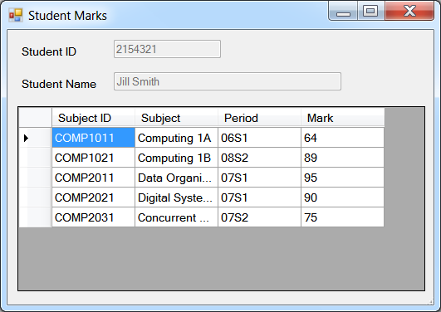
Your first form needs to pass a dataset containing the tables for student mark and subject, You need to add this query to form one so that the population of the dataset is being done in form one and it is being based to the second form, you also need to pass in the student ID.
The partial code for FORM2 is below. You are required to fill in the blanks.

using System;
using System.Collections.Generic;
using System.ComponentModel;
using System.Data;
using System.Drawing;
using System.Linq;
using System.Text;
using System.Threading.Tasks;
using System.Windows.Forms;

namespace Week10Lab
{
public partial class Form2 : Form
{
DataSet students;
int studentID;
public Form2(DataSet students, int studentID)
{
this.studentID = studentID;
this.students = students;
InitializeComponent();
}

private void Form2_Load(object sender, EventArgs e)
{
//***********************
// write a LINQ query which will select the student
// name based on their ID, note the
// Dataset and the ID are being passed in
//***********************
var nameList = query.ToList();
txt_name.Text = nameList[0].name;
txt_id.Text = studentID.ToString();

DataTable dt = new DataTable();
dt.Columns.Add("Subject ID", typeof(string));
//ADD COLUMN FOR Subject
//ADD COLUMN FOR Period
//ADD COLUMN FOR Mark

//Complete the following LINQ query. You need to think
//about the tables you have and the how you plan to join them
// you also need to consider the were clause since we only
// want to bring back the results for a single student.

var marksQuery = // YOU SHOULD DO THIS BIT
select dt.LoadDataRow(new object[]
{
m.Field<string>("SubjectId"),
s.Field<string>("sname"),
m.Field<string>("period"),
m.Field<int>("mark")
}, false);
marksQuery.CopyToDataTable();
dgv_marks.DataSource = dt;

dgv_marks.AllowUserToDeleteRows = false;
dgv_marks.AllowUserToAddRows = false;
for (int x = 0; x < dgv_marks.ColumnCount; x++)
dgv_marks.Columns[x].ReadOnly = true;
}
}
}

Extended Work – You are not required to do the following and no solutions are available for the following.
- Consider changing the first select statement we looked at into a linq statement, you may or may not see this as important. Linq is more complicated than SQL.
- On Form 2, place a button on the form which will toggle the marks being editable or non-editable.
- Add a new button called add mark. This will open a new form, where subject can be chosen from a combobox, period from an entered and the mark. Note that we already know the student.
- Add a new button called review and save. This will bring back all the rows which have been marked as new or amended. And display them to the user. The user then can click Save or Cancel. Note on Saving.
The rows need to be identified on the Marks DataTable/DataSet which corresponds to our table. And the changes applied to them, as we have a different view of the data. You will also need to use the CommandBuilder to add the relevant commands to the DataAdapter for the marks table. You need to think carefully about where is the best to write the changes back to the database.

SOLUTIONS TO THE BASIC CODE ARE AS FOLLLOWS – ONLY LOOK AT THIS A REFERENCE (NO CUT AND PASTE POSSIBLE!) AND ONLY IF YOU REALLY HAVE TO!

THE CODE FOR FORM2

THE CODE FOR FORM 1

